Types of Learning

• Supervised learning • the data is (x, f(x)) ‐‐ you are told the answer

• Unsupervised learning • only given x, learn to “organize” the data

• Reinforcement learning • you get feedback on potential answers you try • x→ try something → get feedback

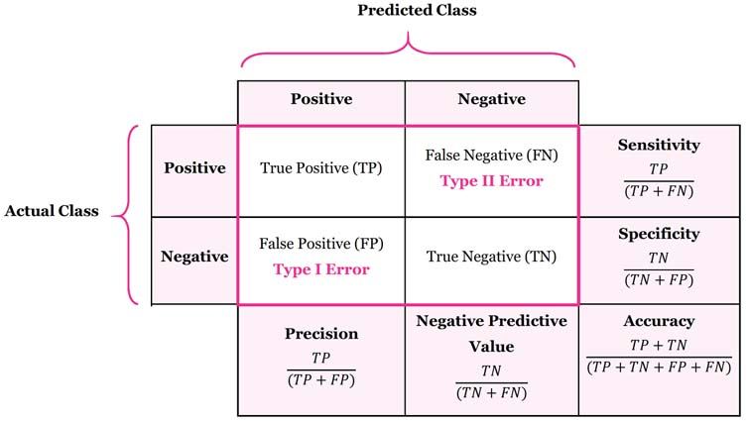

Accuracy is used when the True Positives and True negatives are more important while F1-score is used when the False Negatives and False Positives are crucial